Project Design Phase-II
Data Flow Diagram & User Stories

Date | 30 September 2026
Team ID | SWTID-2026-3555
Project Name | AI Study Buddy
Maximum Marks | 4 Marks

Data Flow Diagrams:
A Data Flow Diagram (DFD) is a traditional visual representation of the information flows within a system. A neat and clear DFD can depict the right amount of the system requirement graphically. It shows how data enters and leaves the system, what changes the information, and where data is stored.
AI Study Buddy – DFD Level 0 (Context Diagram):
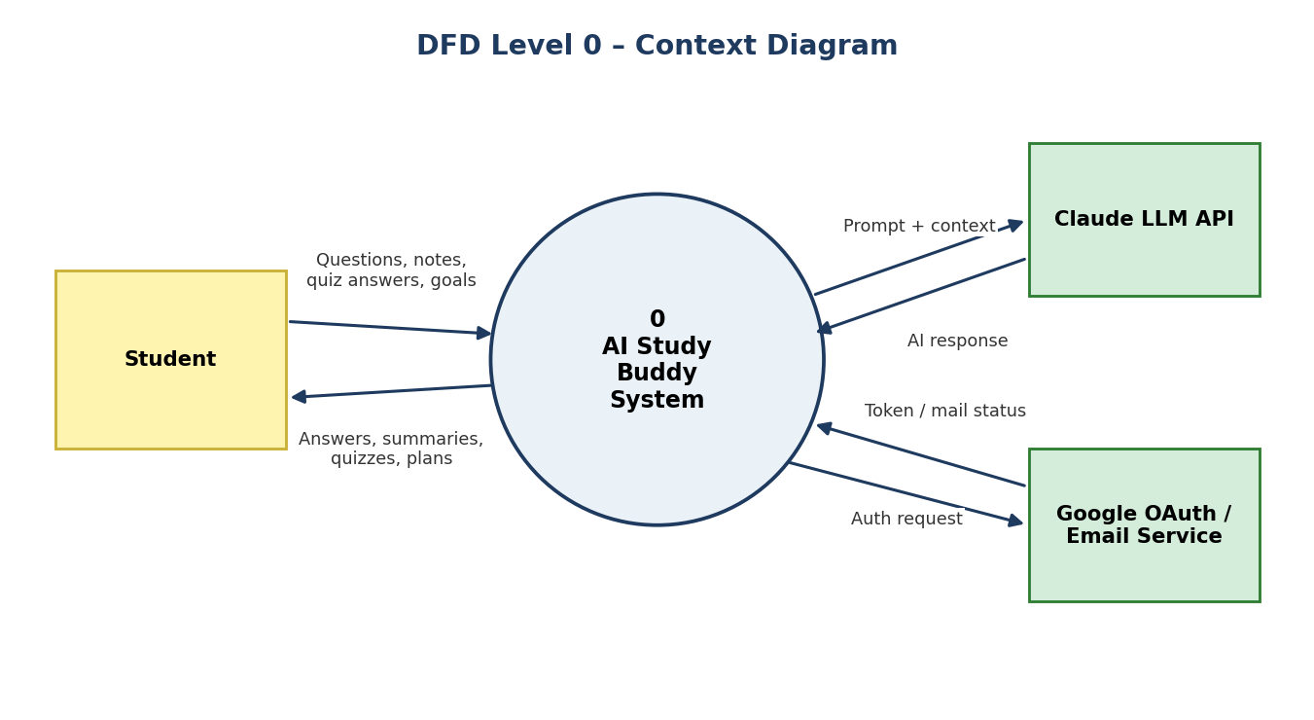
AI Study Buddy – DFD Level 1:
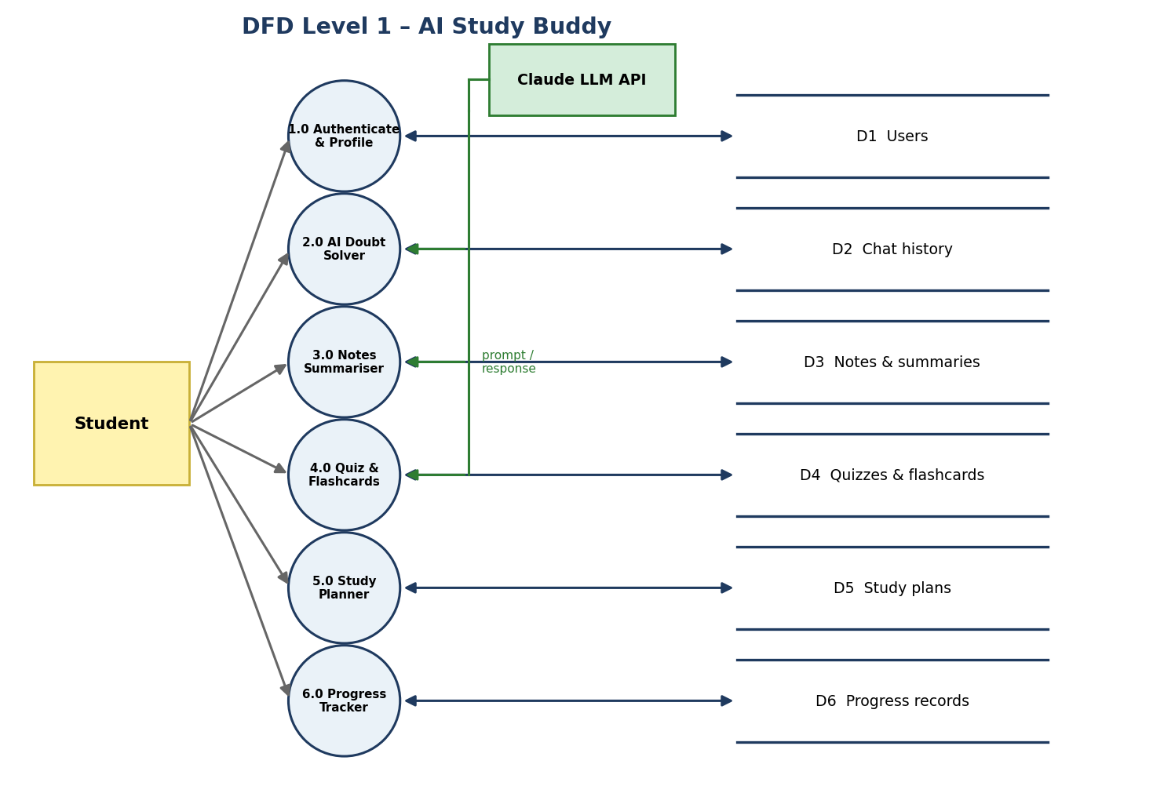

User Stories
Use the below template to list all the user stories for the product.
User Type | Functional Requirement (Epic) | User Story Number | User Story / Task | Acceptance criteria | Priority | Release
Student | Registration | USN-1 | As a user, I can register for the application by entering my email, password, and confirming my password. | I can access my account / dashboard | High | Sprint-1
 |  | USN-2 | As a user, I will receive a confirmation email once I have registered for the application. | I can receive the confirmation email & click confirm | High | Sprint-1
 |  | USN-3 | As a user, I can register for the application through Gmail. | I can register & access the dashboard with Google login | Medium | Sprint-1
 | Login | USN-4 | As a user, I can log into the application by entering email & password. | I can log in and reach my dashboard | High | Sprint-1
 | Dashboard | USN-5 | As a user, I can see a dashboard with quick links to all study tools. | Dashboard shows chat, notes, quiz and planner shortcuts | High | Sprint-1
 | AI Doubt Solver | USN-7 | As a user, I can type a question and receive a clear step-by-step answer from the AI tutor. | I receive a relevant answer within a few seconds | High | Sprint-1
 | Notes Summariser | USN-10 | As a user, I can upload notes and get a short summary with key points. | Summary is generated and can be saved | High | Sprint-2
 | Quiz | USN-14 | As a user, I can generate a quiz from a topic or my notes and see my score. | Quiz is generated; score and explanations are shown | High | Sprint-3
 | Flashcards | USN-16 | As a user, I can generate flashcards from my notes. | Flashcards are created and can be reviewed | Medium | Sprint-3
 | Study Planner | USN-19 | As a user, I can create a personalised study plan for my exam date. | Plan with daily tasks is created and saved | High | Sprint-4
 | Progress Tracking | USN-21 | As a user, I can view my progress and weak topics. | Dashboard shows scores and topic-wise progress | High | Sprint-4
Mobile user | Access | USN-24 | As a mobile user, I can use the application in my phone browser with a responsive layout. | All pages fit and work on a phone screen | Medium | Sprint-4
Support / Customer care executive | Support | USN-25 | As a support executive, I can view user queries and feedback ratings on AI answers. | Feedback list is visible with ratings | Low | Sprint-4
Administrator | Administration | USN-22 | As an administrator, I can manage users and monitor application usage. | Admin can view, block/unblock users and see usage statistics | Medium | Sprint-4

